SOFTWARE ARCHITECTURE DOCUMENT
Datapath Driver Development

Project | Datapath Driver Development
Customer | Kyocera SLD Laser, Inc.
Prepared by | Tessolve Semiconductors
Date | 31st March 2026
Version | V 0.1
Classification | CONFIDENTIAL AND PROPRIETARY

NXP LX2160A ↔ LA1224 - Bidirectional Ethernet-to-PCIe Baseband Datapath

Revision History
Revision | Author | Date | Comments
V 0.1 | Tessolve Semiconductors | 31st March 2026 | Initial draft. Architecture defined based on analysis of Kyocera-provided LSDK 2108 / SDK 3.2 filesystem and reference documentation. Software architecture document created (Milestone 1).

List of Figures
Figure Number | Figure Title | Page Number
Fig. 1 | Master System Architecture Flow - LX2160A ↔ LA1224 Bidirectional Datapath | 9

List of Tables
Table Number | Table Title | Page Number
1 | Kyocera-Provided File System Overview | 4
2 | Component Responsibility Summary | 7
3 | Component Descriptions | 10
4 | Interface Summary | 12
5 | Assumptions and Open Points | 13

Contents
Revision History 2
List of Figures 2
List of Tables 2
1. Introduction 4
2. Functional Overview 4
3. System Context 7
3.1 LX2160A - Host Processor 7
3.2 LA1224 - Baseband Accelerator 7
3.3 Component Responsibility Summary 7
4. Architecture Overview 8
5. Component Descriptions 10
5.1 DPDK Host Application 10
6. Operational Flow 11
6.1 System Boot and Initialization 11
6.2 Steady-State Frame Processing Loop 11
7. Interfaces and Integration Points 12
8. Deployment and Build 12
8.1 Kyocera-Provided Artifacts - Ready to Deploy 12
9. Assumptions and Open Points 13

1. Introduction
This document describes the software architecture of the bidirectional Ethernet-to-PCIe datapath being developed by Tessolve Semiconductors for the Kyocera 5G platform. The system transports 10 Gbps Ethernet frames from an NXP LX2160A host processor to an NXP LA1224 baseband accelerator for offloaded signal processing and returns the processed results to the network at line rate.
The core architectural principle is zero-copy on the steady-state path. All frame data movement between the two processors is performed by the LA1224 DMA engine, which reads from and writes to a hugepage-backed shared memory region made accessible over the PCIe interconnect through address translation hardware. The host CPU is not involved in frame data movement on the hot path.

2. Functional Overview
Kyocera has shared the project file system containing the NXP LSDK 2108 SDK version 3.2 repository and associated reference documentation. The filesystem is used to understand the software stack, identify build dependencies, and define the integration flow for the target platform.

We referred from: link (The package name and path are tabulated below)

Table 1: Kyocera-Provided File System Overview
Document / Package | Path | Description
LA1224 RDB BSP User Guide Rev 3.2 | Tessolve-Kyocera\Docs\LA1224-RDB-BSPUG_Rev.3.2.pdf | Primary BSP reference for the LA1224-RDB board. Covers SDK build, boot sequence, DPDK bring-up, and PCIe bbdev datapath configuration.
NXP LA1224 & LX2160 Platform Update | Tessolve-Kyocera\Docs\NXP LA1224 & LX2160 Update.pdf | Platform-level update covering LA1224 and LX2160A integration, PCIe connectivity, and SDK release notes.
FR1/FR2 Test Tool User Guide | Tessolve-Kyocera\Docs\FR1FR2TTUG.pdf | User guide for the FR1/FR2 RF test tool used for over-the-air validation.
VSPA DSP Core Library Introduction | Tessolve-Kyocera\Docs\NXP-NE-DspCore_VSPA_0LibraryIntro.pdf | Introduction to the VSPA DSP core library used in LA1224 signal processing firmware.
LA1235 B0 Document | Tessolve-Kyocera\Docs\LA1235_B0.pdf | NXP LA1235 reference document (related platform).
Linux 5.15 RT Boot Artifacts | Tessolve-Kyocera\Tools\boot_LS_arm64_lts_5.15.tgz | Complete boot partition for Linux 5.15.71-rt51. Contains kernel Image (42 MB), device trees (fsl-la1224-rdb.dtb, fsl-la1224-rdb-revc.dtb), boot script (la1224rdb_boot.scr), and secure boot headers.
Linux 5.10 Boot Artifacts | Tessolve-Kyocera\Tools\boot_LS_arm64_lts_5.10.tgz | Alternate boot partition for Linux 5.10 LTS baseline (non-RT).
Ubuntu 20.04 Root Filesystem | Tessolve-Kyocera\Tools\rootfs_lsdk2108_ubuntu_main_arm64.tgz | Complete LSDK 2108 Ubuntu 20.04 rootfs for AArch64. Contains DPDK 22.11.4 pre-built libraries and headers, la12xx BBdev PMD (librte_baseband_la12xx.a), LA1224 e200 firmware ELF images (usr/lib/firmware/), VSPA .eld images, DPAA2 runtime scripts (usr/local/dpdk/dpaa2/), and pre-built test applications.
Flexbuild SDK 3.2 | Tessolve-Kyocera\Tools\flexbuild_la12xx_sdk3.2_ext\ | NXP Flexbuild SDK 3.2 build framework. Contains source packages for the LA1224 host software (components/apps/networking/hostsw_la12xx/), PCIe kernel driver sources (hostsw_la12xx/kernel_driver/yami/), build scripts, and SDK documentation.
LA1224 RDB Rev C Flash Image | Tessolve-Kyocera\Tools\firmware_la1224rdb_revc_xspiboot.img | Prebuilt xSPI boot image for the LA1224-RDB Rev C board.
DFE Reference Project | Tessolve-Kyocera\Tools\sw1024206-DFE Ref v5.0.9(0.6)\DFE_Ref | Digital Front-End reference project including VSPA SDK, host-VSPA interface sources, LCF files, and reference libraries for DFE development.
FR1/FR2 Test Tool v5.0 | Tessolve-Kyocera\Tools\sw988950-FR1 FR2 Test Tool(5.0) | FR1 and FR2 RF test tool binary package (version 5.0).
LA12xx BSP 3.2 Archive | Tessolve-Kyocera\Tools\sw894032-La12xx BSP 3.2(3.2).tgz | Original BSP 3.2 tarball as delivered by NXP.
ASF SIB Release v1.0 | Tessolve-Kyocera\Tools\sw941310-ASF_SIB_Release_v1.0-Binary.zip (1.0) | ASF SIB binary release package.

Key artifacts identified within the filesystem that are directly relevant to the datapath development:
Artifact | Path within rootfs or SDK | Role
geul_e200_cpeipc.elf | Tessolve-Kyocera\Tools\rootfs_lsdk2108_ubuntu_main_arm64\usr\lib\firmware\ | LA1224 IPC passthrough firmware (1.3 MB). Primary candidate for PCIe bbdev datapath bring-up.
geul_e200_pci.elf | Tessolve-Kyocera\Tools\rootfs_lsdk2108_ubuntu_main_arm64\usr\lib\firmware\ | LA1224 FECA/PCIe firmware (199 KB). LDPC encode/decode mode.
geul-vspa0.eld through geul-vspa7.eld | Tessolve-Kyocera\Tools\rootfs_lsdk2108_ubuntu_main_arm64\usr\lib\firmware\ | VSPA DSP core images for LA1224 signal processing.
librte_baseband_la12xx.a | Tessolve-Kyocera\Tools\rootfs_lsdk2108_ubuntu_main_arm64\usr\local\lib\ | Pre-built la12xx BBdev PMD static library (79 KB). Links into the host application.
dynamic_dpl.sh | Tessolve-Kyocera\Tools\rootfs_lsdk2108_ubuntu_main_arm64\usr\local\dpdk\dpaa2\ | Runtime script for DPAA2 object creation (dpmac, dpni, dprc).
PCIe kernel driver source (yami.ko) | Tessolve-Kyocera\Tools\flexbuild_la12xx_sdk3.2_ext\components\apps\networking\hostsw_la12xx\kernel_driver\yami\ | Source for the PCIe kernel driver module. Must be compiled against Linux 5.15 RT kernel headers.
dpdk-bbdev_raw_app | Tessolve-Kyocera\Tools\rootfs_lsdk2108_ubuntu_main_arm64\usr\local\bin\ | Pre-built bbdev test application. Used for first integration test before custom app development.
dpdk-geul_ipc_benchmark | Tessolve-Kyocera\Tools\rootfs_lsdk2108_ubuntu_main_arm64\usr\local\bin\ | Pre-built IPC benchmark application. Used for baseline throughput measurement.

The provided filesystem is used to understand the software stack and architecture of the platform.

3. System Context

3.1 LX2160A - Host Processor
The LX2160A is a 16-core ARMv8-A network processor running Linux 5.15 PREEMPT_RT (kernel 5.15.71-rt51, provided in the Kyocera repository). It acts as the PCIe Root Complex and owns the 10G Ethernet interface through the DPAA2 hardware subsystem. The LSDK 2108 Ubuntu 20.04 rootfs, DPDK 22.11.4, all required static libraries, the la12xx BBdev PMD, and a suite of pre-built test applications are delivered to the Kyocera repository and are ready to deploy.

3.2 LA1224 - Baseband Accelerator
The LA1224 is a 5G baseband accelerator running NXP-supplied firmware on its six e200 PowerPC control cores. Ten pre-built ELF firmware images and sixteen VSPA .eld images are present in the repository at rootfs/usr/lib/firmware/. The IPC, DMA, FECA, and VSPA subsystems are all implemented within these pre-built images. The firmware variant to be used for the PCIe bbdev datapath must be selected from the available images in consultation with Kyocera before board bring-up begins.

3.3 Component Responsibility Summary

Table 2: Component Responsibility Summary
Component | Owner | Status in Repository
DPDK host application (eth_pcie_datapath) | Tessolve | Makefile and meson.build present. Source to be written.
PCIe kernel driver (yami.ko) | Tessolve - NXP | Source present in hostsw_la12xx/kernel_driver/yami/. Must be compiled against the 5.15 RT kernel.
la12xx BBdev PMD | Tessolve - NXP | librte_baseband_la12xx.a (79 KB) present.
DPDK 22.11.4 libraries | Tessolve - NXP | 130+ static libraries in rootfs/usr/local/lib/. Ready to link.
Linux kernel 5.15 RT image | Tessolve - NXP | Image (42 MB) and dtb present in boot folder and it is ready to flash.
LA1224 e200 firmware (10 ELF variants) | Tessolve - NXP | All images are present in rootfs/usr/lib/firmware/. No modem-side development needed.
LA1224 VSPA firmware (8 core instances + warmup) | Tessolve - NXP | geul-vspa0.eld through geul-vspa7.eld and warmup variants present. Ready to deploy.
DPAA2 object creation (DPL/DPC) | Tessolve - NXP | dynamic_dpl.sh present. Creates dpmac, dpni, dprc at runtime. No static DPL file required.

4. Architecture Overview
The architecture places all custom implementation on the LX2160A host side, while the LA1224 operates using NXP-supplied firmware and hardware acceleration blocks. The processors communicate over PCIe Gen3 x8 using IPC descriptor rings in LA1224 BAR2 SRAM along with a Host Interface control structure for synchronization and control.
On the LX2160A, the DPDK host application bridges the DPAA2 Ethernet interface and the la12xx BBdev interface. The application receives frames, submits them to LA1224 via IPC, waits for completion of notifications through MSI, and transmits processed frames back to the network. All frame data transfers are performed by the LA1224 DMA engine via PCIe.
Figure 1 provides the end-to-end bidirectional Datapath between the Test PC, LX2160, and LA1224 accelerator. The flow represents the steady-state packet processing pipeline.
On the RX path, Ethernet frames generated from the Test PC are received by the LX2160 through the MAC/PHY and WRIOP Datapath, queued via QBMAN, and transferred to DDR using DMA. The DPDK application processes the packets in user space using rte_eth_rx_burst(), performs payload extraction, and prepares LDPC operations using bbdev. These operations are then offloaded to LA1224 over PCIe for LDPC encoding and OFDM modulation.
On the TX path, the processed data from LA1224 is written back to DDR via PCIe DMA. The DPDK application retrieves the completed operations, performs validation (e.g., CRC), and transmits the packets using rte_eth_tx_burst(). The data flows through QBMAN and WRIOP to the MAC/PHY and is sent back over Ethernet to the Test PC.

Figure 1: Master System Architecture Flow - LX2160A ↔ LA1224 Bidirectional Datapath

Figure 1 - Master System Architecture Flow: LX2160A LA1224 Bidirectional Datapath (Boot Sequence + Steady-State Frame Processing Loop)
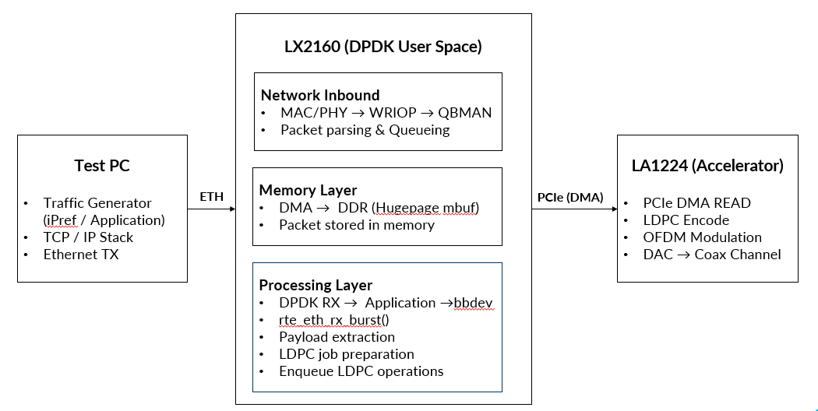

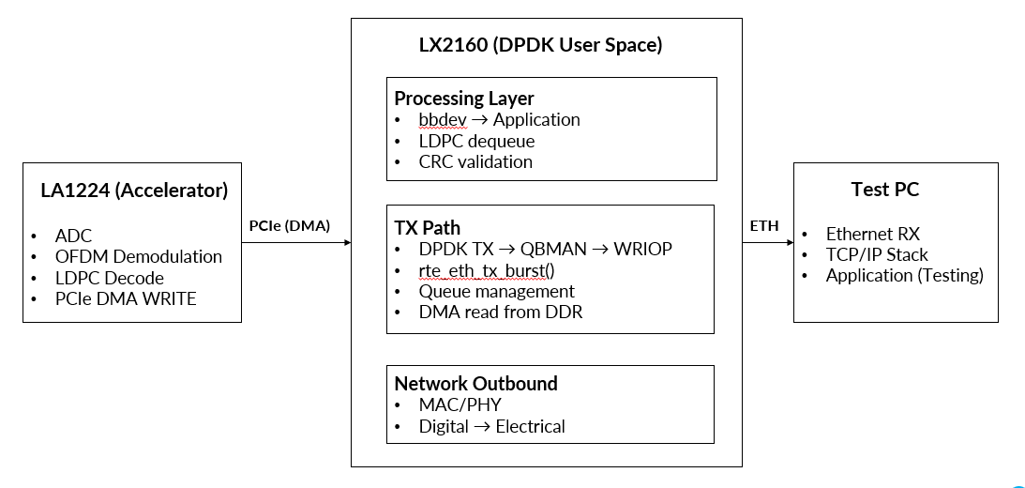

5. Component Descriptions
Table 3: Component Descriptions
Component | Owner | Responsibility
DPDK Host Application | Tessolve | Ethernet burst receive/transmit, bbdev enqueue/dequeue, IPC ring management, flow control, per-direction counters.
yami.ko (PCIe kernel driver) | Tessolve - NXP | PCIe endpoint enumeration, BAR2 mapping, iATU outbound window, 8 MSI lines, hugepage allocation, /dev/gulipc0 character device, LA1224 firmware download.
la12xx BBdev PMD | Tessolve - NXP | Standard bbdev interface. Translates bbdev operations into IPC ring descriptors over PCIe. Communicate with yami.ko via /dev/gulipc0 ioctl + eventfd for MSI delivery.
LA1224 NXP Firmware (geul_e200_cpeipc.elf / geul_e200_pci.elf) | Tessolve - NXP | IPC descriptors dequeue, DMA initiation, processing dispatch (passthrough or FECA LDPC), output descriptor enqueue, MSI write to host. Runs on e200 cores under FreeRTOS.
LA1224 DMA Engine | Kyocera Hardware | PCIe DMA inbound (hugepage to SRAM) and outbound (SRAM to hugepage). Both directions are initiated by LA1224 firmware. No CPU involvement on either side.
VSPA firmware (geul-vspa0..7.eld) | Tessolve - NXP | DSP processing cores on LA1224. Loaded by NXP firmware at boot. Available for OFDM, FFT, and signal processing workloads.

5.1 DPDK Host Application
The DPDK host application initializes one Ethernet port through the DPAA2 PMD and two bbdev queues through the la12xx PMD, then enters a tight polling loop on a dedicated lcore with no sleep or interrupt wakeup on the critical path.
In the ingress phase, the application collects frames from the NIC via rte_eth_rx_burst. Each frame is already resident in a hugepage mbuf placed there by the NIC DMA hardware. A bbdev raw operation carrying the hugepage physical address and frame length is prepared for each frame and submitted to the Host-to-Modem queue via rte_bbdev_enqueue_enc_ops. No frame payload is read or copied.
In the egress phase, the application polls the Modem-to-Host queue via rte_bbdev_dequeue_dec_ops. Each completed operation indicates that the LA1224 NXP firmware has finished processing and has written the result back to the hugepage buffer. The application passes these buffers directly to rte_eth_tx_burst. No payload copy occurs.
The application maintains per-direction counters for frames received, transmitted, enqueued, dequeued, dropped due to ring backpressure, and bbdev enqueue errors. The build system is provided in eth_pcie_datapath/host/ with both a Makefile (using RTE_SDK/RTE_TARGET) and a meson.build alternative.

6. Operational Flow
The complete operational flow of the system is captured in Figure 1.

6.1 System Boot and Initialization
The LX2160A boots from SD card or eMMC via U-Boot using the kernel image, device tree, and boot script provided in the Kyocera repository. The Linux 5.15 PREEMPT_RT kernel starts, and the DPAA2 Management Complex firmware is loaded. DPAA2 network objects (dpmac, dpni, dprc) are created dynamically by dynamic_dpl.sh at runtime via the vfio-fsl-mc binding path - no static DPL/DPC file is required. One 1 GB hugepage is allocated; the boot_vspa.sh script must be updated from its current 24 × 2 MB configuration before the DPDK application starts.
The yami.ko kernel module is inserted. It enumerates the LA1224 as a PCIe endpoint, maps the 128 MB BAR2 region, and registers 8 MSI interruption lines. The selected NXP firmware ELF image is downloaded to the LA1224 over PCIe during module probe. The LA1224 boots on its e200 cores, initializes the IPC descriptor rings (16 descriptors per channel), and readies the FECA hardware engine.
The DPDK EAL initializes on the host, and the la12xx PMD opens /dev/gulipc0 to retrieve the PCIe memory map. A flag-based handshake confirms readiness on both sides: the host writes HOST_MEM_READY and IPC_LIB_READY to the Host Interface structure in BAR2 SRAM. LA1224 NXP firmware writes FECA_READY in acknowledgement. The DPDK application polls this flag with a 10-second timeout. Once the handshake completes, the polling loop starts on a dedicated lcore with no sleep.

6.2 Steady-State Frame Processing Loop
An Ethernet frame arriving on the LX2160A 10G port is deposited by the WRIOP hardware and DPAA2 DMA engine into a hugepage-backed mbuf. The DPDK application collects the mbuf reference via rte_eth_rx_burst and receives the hugepage physical address and frame length. A bbdev raw operation is prepared for each frame and submitted to the la12xx PMD via rte_bbdev_enqueue_enc_ops - no payload is read or copied.
The la12xx PMD writes an IPC descriptor to the Host-to-Modem ring in LA1224 BAR2 SRAM over PCIe. The NXP IPC driver on the LA1224 dequeues the descriptor and the DMA engine transfers the frame payload from the hugepage into LA1224 on-chip SRAM over PCIe Gen3 x8 (inbound DMA).
Once processing is completed, the DMA engine writes the result back from SRAM to the LX2160A hugepage buffer (outbound DMA). A completion descriptor is written to the Modem-to-Host IPC ring. The LA1224 NXP firmware writes to the 64 KB MSI region at the top of the 2 GB PCIe address window. The yami.ko kernel driver receives this MSI and routes it via eventfd to the la12xx PMD in user space. The DPDK application dequeues the completed bbdev operation via rte_bbdev_dequeue_dec_ops and passes the hugepage buffer directly to rte_eth_tx_burst. The NIC DMA reads directly from the hugepage and transmits the frame to the 10G Ethernet network. No host CPU memory copy occurs at any point on this path.

7. Interfaces and Integration Points
Table 4: Interface Summary
Interface | Mechanism
10G NIC to DPDK application | DPAA2 net PMD (librte_net_dpaa2.a). Frames arrive at hugepage mbufs via NIC DMA. DPAA2 objects created by dynamic_dpl.sh at runtime.
DPDK application to la1224 PMD | Standard bbdev API: rte_bbdev_enqueue_enc_ops / rte_bbdev_dequeue_dec_ops. Operations carry hugepage physical addresses. No frame payload passes this interface.
la1224 PMD to yami.ko | Character device /dev/gulipc0. Ioctls retrieve PCIe memory map and register hugepage addresses. Eventfd carries MSI completion signals to user space.
Host to LA1224 - data plane | PCIe DMA transfers initiated by LA1224 NXP firmware DMA engine. IPC descriptor rings in BAR2 SRAM carry host physical addresses and lengths. Ring depth: 16 descriptors per channel (tunable).
Host to LA1224 - control plane | Host Interface structure in BAR2 SRAM: handshake flags, MSI address/data values, per-core debug log buffers, runtime statistics counters. Readable from host via PCIe at any time through sysfs attributes.
LA1224 to host - completion signal | MSI write by LA1224 NXP firmware DMA engine to the 64 KB MSI region at the top of the 2 GB iATU PCIe window. Routed by yami.ko via eventfd to la12xx PMD in user space.

8. Deployment and Build

8.1 Kyocera-Provided Artifacts - Ready to Deploy
The following are delivered in the kyocera’s LSDK 2108 repository and require no build or modification before deployment:
- Linux 5.15 PREEMPT_RT kernel image and fsl-la1224-rdb.dtb device tree
- Ubuntu 20.04 rootfs with DPDK 22.11.4, all static libraries, headers, and pre-built test binaries
- la12xx BBdev PMD (librte_baseband_la12xx.a) and rte_pmd_bbdev_la12xx.h header
- LA1224 e200 firmware ELF images (10 variants) and VSPA .eld images (8 core instances + warmup)
- dynamic_dpl.sh for DPAA2 object creation at runtime
- dpdk-test-bbdev, dpdk-bbdev_raw_app, dpdk-geul_ipc_benchmark, dpdk-testpmd pre-built test applications

9. Assumptions and Open Points
Table 5: Assumptions and Open Points
Open Point | Detail and impact
LA1224 Firmware variant selection | geul_e200_cpeipc.elf (IPC passthrough, 1.3 MB) and geul_e200_pci.elf (FECA/PCIe, 199 KB) are both present in the repository. The correct variant must be confirmed with Kyocera before board bring-up. Selecting the wrong variant will cause the IPC rings to fail to initialize.
Hugepage size in boot_vspa.sh | boot_vspa.sh currently sets 24 × 2 MB = 48 MB hugepages. The DPDK host application requires 1 GB of hugepages. This script must be updated before the application starts. Confirmed gap from filesystem analysis.

